FOR IMMEDIATE RELEASE

EDWIN BERRY MANOR APARTMENTS TO BE PRESERVED AS AFFORDABLE HOUSING IN CHICAGO’S UP-AND-COMING WOODLAWN NEIGHBORHOOD
The NHP Foundation acquired the senior property in the same area that will serve as home to the Obama Library
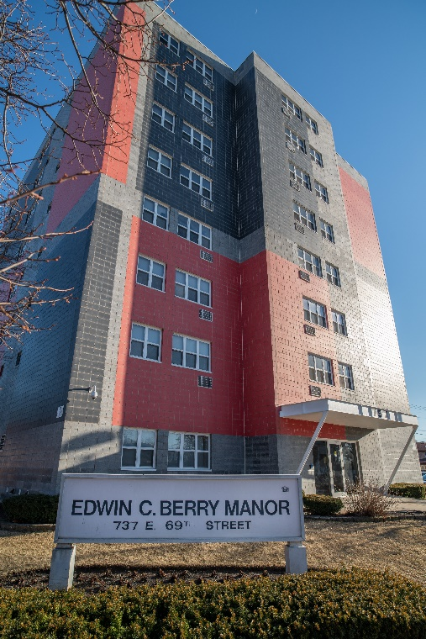
November 19, 2019 – Chicago, IL – In keeping with its mission to preserve affordable housing, national not-for-profit The NHP Foundation (“NHPF”) has acquired the Edwin C. Berry Manor Apartments, a senior, Section 8 property located at 737 E. 69th St. in Chicago. The acquisition was made possible by a financial partnership with Low Income Investment Fund (LIIF).
The NHP Foundation will preserve and maintain the 57-unit affordable property built in 1991, making it the fourth property the organization has acquired or built in Chicago in the last five years and the first specifically for seniors.
“According to a recent report by the Joint Center for Housing Studies of Harvard University, 37 percent of Chicago households age 65 to 79—or about 220,000--are cost-burdened, compared with 30.8 percent for the nation overall,” said Dick Burns, President & CEO of NHPF. “The acquisition and preservation of Berry Manor represents an opportunity to provide older Chicagoans in need with critical housing and a better quality of life.” Operation Pathways, the Resident Services affiliate of NHPF, will provide onsite services.
Edwin C. Berry Manor Apartments is well-located in an up-and-coming neighborhood that is brimming with new investment, due in part to future construction of the Obama Library. Added Mecky Adnani, project lead and Sr. VP, NHPF, “Building our affordable housing portfolio in Chicago, including this presence in the growing neighborhood of Woodlawn, is part of a strategic effort to leverage our know-how and that of our great partners to increase the availability of rental units for low to middle income residents.”
Financing from the Low Income Investment Fund (LIIF) made the acquisition possible. “The preservation of Edwin C. Berry Manor Apartments represents the best of what private/public partnerships can produce in Chicago,” said Holly Denniston-Chase, LIIF’s Deputy Director of the Mid-Atlantic Region. “NHPF, a long-time LIIF borrower, will ensure that this property remains quality affordable housing dedicated to seniors at this location for the long term.”

###
About The NHP Foundation
Headquartered in New York City with offices in Washington, D.C., and Chicago, I.L., The NHP Foundation (NHPF) was launched on January 30, 1989, as a publicly supported 501(c)(3) not-for-profit real estate corporation. NHPF is dedicated to preserving and creating sustainable, service-enriched multifamily housing that is both affordable to low and moderate income families and seniors, and beneficial to their communities. NHPF also provides a robust resident services program to nearly 18,000 community residents. Through partnerships with major financial institutions, the public sector, faith-based initiatives, and other not-for-profit organizations, NHPF has 53 properties, including more than 8,000 units, in 15 states and the District of Columbia. For more information, visit www.nhpfoundation.org.

